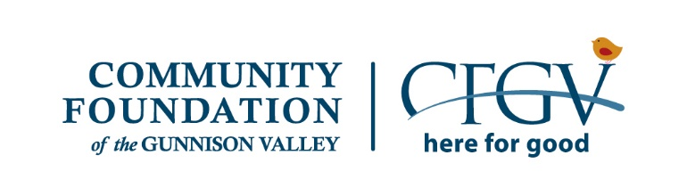

CFGV Community Grants Application

Please choose only one. Are you a:
- 501(c)(3) nonprofit organization with headquarters in Gunnison County
- 501(c)(3) nonprofit organization with headquarters outside of Gunnison County
- Group under fiscal sponsorship
- Government entity (Gunnison County, Gunnison Watershed School District, Western Colorado University, etc.)
- Faith-based organization
- Collaboration

FOR FISCAL SPONSORSHIPS:
Please enter information for the Group that is housed under a fiscal sponsorship. Contact information for the sponsoring organization will be provided in the next section.

What is the name of the Group under fiscal sponsorship?
Who is the main contact person for the sponsored Group?
What is the phone number for the sponsored Group?
What is the email of the main contact identified above?

General Information

IMPORTANT: The word "Applicant" refers to the organization submitting the proposal for itself or one of its departments, or as a fiscal sponsor for a smaller group, or as the lead organization in a collaboration. The "Applicant" is responsible for any funds received, and an authorizing official from this organization must sign the proposal. The word "Group" refers to the entity that is actually undertaking the program(s) described in this proposal. See the Guidelines to learn who signs this application.
Legal Name of Applicant Organization
Applicant DBA (Doing Business As), if
different than legal name
Name of Group, if applicable EIN (Federal Tax Identification Number) Mailing Address of Group
City
State

Zip Code
Physical Address
City
State

Zip Code
Phone Number
Website
Year Founded

Applicant's Contact Person For This Application
Name
Position or Title
Email
Phone

Group's Contact Person For This Application

Name
Position or Title
Email
Phone

Grant Request Information
IMPORTANT (contact CFGV if you have questions): ALL 501(c)(3) nonprofit organizations will apply for General Operating support regardless of where they are headquartered; Groups under fiscal sponsorship will apply for General Operating support; Government entities will apply for Project support for programs that are primarily grant-funded; Faith-Based Organizations will apply for Project support for projects/programs that do not require adherence to religious doctrine to participate and are open to all; Collaborations will apply for Project support.

Grant Request Type

Name of Project
- General Operating
- Project (Single applicant)
- Project (Collaboration)

Amount Requested (positive number without commas, decimals or dollar signs)

% Requested (Amount Requested / Total Operating Budget = % Requested) Total Project Budgeted Cost:
% Requested (Amount Requested / Total Cash Project Budgeted Cost = % Requested)
Number of local people you serve in a typical year Number of visitors you serve, if relevant
Please give a one sentence synopsis of what the grant will be used for.

If this application is for a collaboration, please include the Organization Name and Contact information (Name and Email Address) for each partner

Applications must be signed by an individual who is authorized to sign grant proposals on behalf of the Applicant or Group.
Please use your computer mouse to "draw" signature electronically.

Please pick the grant category below that you believe is the best fit for this application. If you are applying for program or project support, this refers to your program or project.
- Arts and Culture
- Historical Tradition and Preservation
- Athletics and Recreation
- Community Development
- Environment
- Education
- Health and Human Services
- Animal Welfare

Mission Statement:

Purpose Statement of the Group:

Whom does the Group serve, what is the need, and why does it matter? Be specific and use numbers where possible. (Max: 125 words)

In general, what do you do? (Max: 125 words)

Based on past evaluations and accomplishments, what difference have you made? (Max: 125 words)

How do you determine the impact of what you do? (Max: 50 words)

Describe your Project. (Max: 125 words)

What do you want to achieve? (Max: 50 words)

How will you find out whether you have achieved this? (Max: 50 words)

How is the COVID-19 pandemic affecting your Group? (Max: 125 words)

Financial and Organization Information
The following questions are required for General Operating requests ONLY!

In which month does your fiscal year start?

Please recall that 'Group' refers to a 501(c)(3) seeking funds for itself or the sponsored entity under fiscal sponsorship.
# of Group's full-time, year-round employees
# of Group's part-time employees, if applicable
# of Group's seasonal employees, if applicable

If your most recently completed year actual revenue and/or expenses was 10% or more different from budget projections, or if there is anything else that might appear to distort your financials to an outside reviewer (such as significant accounts receivable, a
one-time gift or expense, uneven cash flow for seasonal reasons, etc.), please explain. (Max: 75 words)

How many months of operating reserve do you have?

Are you currently undertaking a capital campaign?

Yes No
If yes, are your capital campaign income/expenses incorporated into the organizational budget you will submit?

Yes No
Are you currently undertaking an endowment campaign?

Yes No
If yes, are your endowment campaign income/expenses incorporated into the organizational budget you will submit?

Yes No
In the last three years, has your organization had an audit or financial review conducted by an outside party?

Yes No

If yes, which one?

If it identified any issues, summarize

- Audit
- Financial Review

how you are addressing them.

