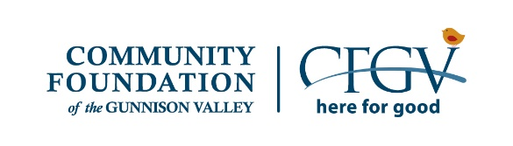
CFGV Community Grants Application
NOTE: THIS DOCUMENT IS FOR REFERENCE ONLY;
YOU MUST SUBMIT YOUR APPLICATION ONLINE AT HTTPS://CFGV.SMAPPLY.ORG

General Information
IMPORTANT: The word "Applicant" refers to the organization submitting the proposal for itself or one of its departments, or as a fiscal sponsor for a smaller group. The "Applicant" is responsible for any funds received, and an authorizing official from this organization must sign the proposal. The word "Group" refers to the entity that is actually undertaking the program(s) described in this proposal. See the Guidelines to learn who signs this application.

Legal Name of Applicant Organization
Applicant DBA (Doing Business As), if
different than legal name
Name of Group, if applicable EIN (Federal Tax Identification Number) Mailing Address of Group
City
State
Zip Code
Physical Address
City
State
Zip Code

Phone Number (XXX-XXX-XXXX) Website
Year Founded

Applicant's Contact Person For This Application
Name
Position or Title
Email
Phone

Group's Contact Person For this Application Name
Name
Position or Title
Email
Phone

Grant Request Information
In 2020, ALL 501c3 nonprofit organizations will apply for General Operating support. Government agencies and will apply for Project support for programs that are primarily grant-funded. Groups under fiscal sponsorship will also apply for Project support. Contact CFGV if you have questions.

Grant Request: CHOOSE ONE

Name of Project
Program/Project Operating

Amount Requested (positive number without commas, decimals or dollar signs)
% Requested (Amount Requested / Total Operating Budget = % Requested) Total Project Budgeted Cost:
% Requested (Amount Requested / Total Cash Project Budgeted Cost=% Requested) Number of local people you serve in a typical year
Number of visitors you serve, if relevant Please give a on sentence synopsis of what the grant will be used for (project requests).

By signing below, we certify that the information contained in this application is true and correct to the best of our knowledge. Please use your computer mouse to "draw" your signature electronically.
Date
/ / (YYYY/MM/DD)

Please pick the grant category below that you believe is the best fit for this application. If you are applying for program or project support, this refers to your program or project.
○Arts and Culture ○ Historical Tradition and Preservation ○ Athletics and Recreation ○ Community Development
○ Environment ○ Education ○ Health and Human Services ○ Animal Welfare

Mission Statement of the Applicant/Purpose Statement of the Group

Whom do you serve and what is the need? Be specific and use numbers where possible. (Max: 125 words)

What do you do? What difference have you made? (Max: 125 words)

How is the COVID-19 pandemic affecting your organization now? (This might refer to your cash reserves, programming, staff planning during disruption, etc. (Max: 125 words)

How do you anticipate the COVID-19 pandemic might affect your organization as you move forward? (Max: 125 words)

