Community Foundation of the Gunnison Valley
Post Office Box 7057
Gunnison, Colorado 81230

Donor Advised Fund

Grant Recommendation Form

FUND NAME:

GRANT INFORMATION Grants to charities are accompanied by a letter recognizing the Advisor(s) recommending the grant from the Fund.

Check here if you’d prefer the Advised Fund to issue your grants anonymously. If checked, the Community Foundation will not disclose the name of the Donor, Advisor, or Fund Name.

Amounts of recommendations: $100 minimum and $50 increments

RECIPIENT CHARITABLE ORGANIZATION Please review the Grant Recommendation Guidelines on the reverse side of this form.

If you have previously recommended grants to any of the organizations listed below, then you needn’t fill out the address and phone number.

Organization Special Instructions/Purpose of Grant Amount
Name:
Address:
Phone:
We would like to recommend a contribution to the Annual Fund (unrestricted) at the Foundation. Please enter amount in the next column.

We would like to recommend a contribution to the Community Grant Fund at the Foundation. Please enter amount in the next column.

TOTAL

If each recommendation is for an amount less than $25,000, it will be reviewed within a week, and, if approved, the Foundation will make the grant within two weeks. If an amount is for more than $25,000, the timing is extended to two weeks for review, and, if approved, up to three weeks for disbursement.

SIGNATURE I acknowledge that I have read the Grant Recommendation Guidelines on the reverse side of this form and the Donor Advised Fund Guidelines and that the above recommendation(s) do not represent the payment of any pledge or other financial obligation.

Signature: Date:

Signature: Date:

(Please be sure to initial page 2 as well)
*******************************************************************************************************************************
OFFICE USE:
Approved by:________________________________________ Date:________________________________

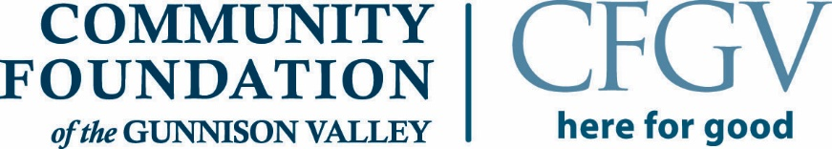

DONOR SERVICES If you have questions regarding this form or you require donor services, please call the Foundation at 970/641-8837 Monday through Friday between 9:00 a.m. and 5:00 p.m. Mountain Time.

Mail completed form to: Community Foundation of the Gunnison Valley
P.O. Box 7057
Gunnison, CO 81230

Email completed form to: alicia@cfgv.org (If emailing this form, please do not mail the original.)

COMMUNITY FOUNDATION OF THE GUNNISON VALLEY

DONOR ADVISED GRANT RECOMMENDATION GUIDELINES

Charitable Organizations
- Grants from a Donor Advised Fund may be made to organizations qualified as tax-exempt under Internal Revenue Code Section 501(c)(3) of 1986 as amended. Each grant must be a minimum of $100 and specified in $50 increments. Grants may not be made to supporting organizations.

Grant Recommendation Limitations
- Grants from a Donor Advised Fund may not be used for any pre-existing pledge or to provide private benefit to donors, advisors, family members or the businesses they control. No tangible benefit, goods or services were or will be received by any individual or entities connected with the Fund (such as school tuition or scholarships sent directly to individuals or that benefit a family member, dues, membership fees, benefit tickets, dinners, event tickets or goods bought at charitable auctions). Nor may grants be used for lobbying, political contributions, or to support political campaign activities. The Fund will not forward any enclosures other than a transmittal letter with the grant check. Under no circumstances may a grant provide a benefit to the donor recommending the distribution, a family member or any entity in which the donor or advisors have 35% of the voting power.

Grant Check Processes
- Grant checks must be made payable to the recipient organization’s legal name, which may be different from the common use name and the Foundation will mail checks to the organization’s official address. Grants will be disbursed directly to the recipient organization. Fund Advisors may not serve as intermediaries.

- If the recommendation is accepted by Foundation, confirmation of the grant award will be mailed to the advisor once the grant has been issued.

Advisors’ Initials _________________ ___________________

