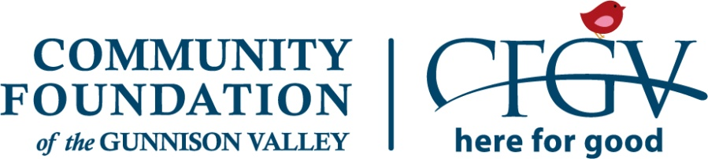

Gunnison Kiwanis Club Scholarship

A Component Fund of the Community Foundation of the Gunnison Valley

2020 Application Instructions and Checklist

To begin your application, visit https://cfgv.smapply.org and create an account (email address and password). You will receive a confirmation email from SurveyMonkey Apply prompting you to follow a link in order to login. If you do not receive this email within 10 minutes, please contact SurveyMonkey Apply Support or the CFGV office.
Once logged in, choose Gunnison Kiwanis Scholarship from the tiles on the homepage to begin your application. Familiarize yourself with the required components of the application (checklist provided below). You can complete the application and uploads in any order you wish.
Hints: You will see a “Save & Continue Editing” button and “Next” button at the bottom of the page when you complete each section of the application. “Save & Continue Editing” will simply save the page while you’re working. “Next” will save your work and take you to the next application section. Use the page tree on the left to navigate between the application and uploads. Be sure to hit “SUBMIT” once everything is completed!
Application Checklist:
- Complete Gunnison Kiwanis Scholarship Application Part I (contact information)
- Complete Gunnison Kiwanis Scholarship Application Part II (narrative questions, household financial information and your personal statement)
- Upload a letter of reference from a teacher or counselor
- Upload a letter of reference from a community member who can speak to your attributes such as: selflessness, ability to help others and/or leadership
- Upload a copy of your college application essay
- Upload a letter of acceptance from the school you plan to attend
- Request that your school guidance counselor email a copy of your official transcript to alicia@cfgv.org by 12:00 pm on Thursday, March 26th (extended from March 15th)
- Review and signature required from both the applicant and a parent. PLEASE NOTE: This is an electronic signature. You will both “sign” with your mouse on a computer screen.
For application assistance, please contact the CFGV office by calling (970) 641-8837 or (970) 349-5966 or emailing alicia@cfgv.org.
You must “SUBMIT” your application by 12:00 pm on Thursday, March 26, 2020 (extended from March 15), in order to be eligible for a scholarship award. Thank you for applying! (Finalists will be asked to come in for an interview).

